What Powers a Company Responsible for Over 100 Years of Innovation

Founded in 1896, IBM or International Business Machines is not only one of the largest companies in the world, but also one of the most innovative. They are responsible for countless technological advancements including WATSON, the hard disk drive, and the magnetic strip found on the back of credit cards. IBM employs over 388,000 employees. With such a large company, their IT department has to be precise with the work that they do. So this begs the question; What powers IBM? Luckily a good buddy of mine is a hardware engineer for them in their corporate headquarters. I was able to reach out to him and find out a little bit about what it takes to run this company.

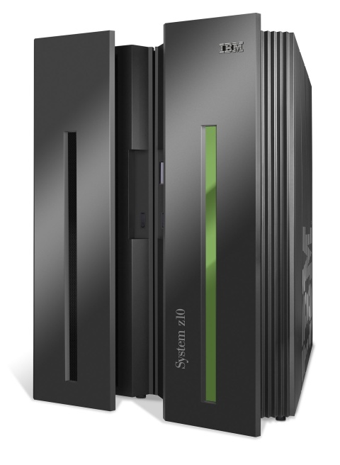**Computational and Mainframe Servers**

**System Z**

The IBM system z uses virtualization and powerful management capabilities to optimize infrastructures allowing large-scale systems to reduce both energy and software costs.

System Z Virtualization Highlights:

* Large-scale consolidation onto a single System z server – host more servers per core
* Reduce floor space requirements, drive down software license fees and save up to 75% on energy costs compared to virtualized x86 alternatives
* Virtualize and share all resources: processor, memory, network, I/O, cryptographic features
* Virtualization combined with protection of sensitive data and improved business continuity / disaster recovery

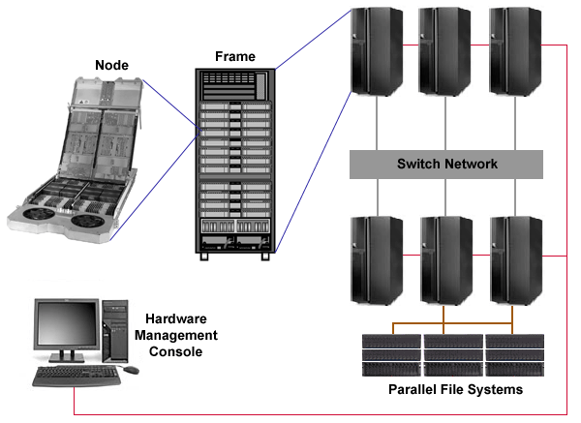Great integration between hardware and software allows the system z to be a premier solution for enterprise security. The system z has the highest security rating for any commercially available server. The z is divided into partitions allowing applications to have their data secure and distinct from other applications. The partitioning also allows different operating systems to run on a single mainframe.

**System P**

Rebranded as IBM Power Systems, the system p is IBMs UNIX based server. IBM calls it “smarter computing.” Power Systems provide an infrastructure the use of the cloud to improve efficiency and deliver secure solutions.

Power System Highlights:

* improve efficiency to enable more focus on business growth
* gain actionable insight in real-time from Business Analytics to improve customer experience and give a competitive edge
* make it easier and less expensive to comply with growing number of industry and government regulations